Project Design Phase
Solution Architecture
Date | 15 February 2025
Team ID | PNT2025TMID_FOBCT_01
Project Name | Food Ordering Behaviour and Consumer Trends
Maximum Marks | 4 Marks

Solution Architecture
Solution architecture is a complex process - with many sub-processes - that bridges the gap between business problems and technology solutions. Its goals are to:
- Find the best tech solution to solve existing business problems.
- Describe the structure, characteristics, behavior, and other aspects of the software to project stakeholders.
- Define features, development phases, and solution requirements.
- Provide specifications according to which the solution is defined, managed, and delivered.
Solution Architecture Diagram
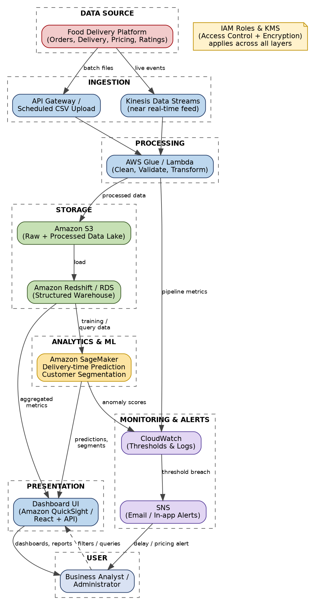
Figure 1: Architecture and data flow of the Food Ordering Behaviour & Consumer Trends Analytics Platform
Flow Summary
- Order, delivery, pricing, and rating data flow from the Food Delivery Platform into the system via batch upload (API Gateway) or a near real-time stream (Kinesis Data Streams).
- AWS Glue / Lambda cleans, validates, and transforms incoming records before writing processed data to an Amazon S3 data lake and Amazon Redshift / RDS data warehouse.
- Amazon SageMaker reads warehouse data to train and run models for delivery-time prediction and customer segmentation.
- The Dashboard UI (Amazon QuickSight or a custom React app backed by an API) reads aggregated metrics and model outputs to render interactive trend dashboards for Business Analysts and Administrators.
- CloudWatch continuously monitors pipeline metrics and model anomaly scores; when a threshold is breached (e.g. delivery delay spike in a zone), SNS pushes an email/in-app alert to the analyst.
- IAM roles and KMS-managed encryption keys enforce access control and protect data at rest and in transit across every layer.

